**CTF Challenge: Evading IDS, Firewall and Honeypots**



**What is Evading IDS, Firewall and Honeypots?**

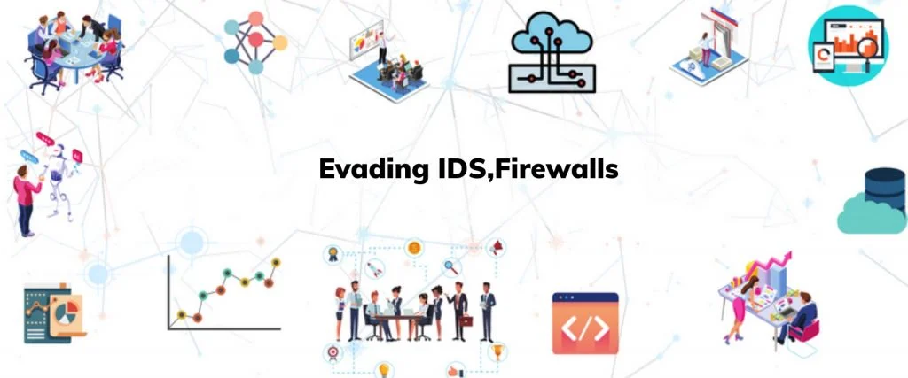

"Evading IDS, Firewall, and Honeypots" refers to techniques and methods used by attackers to bypass or avoid detection by Intrusion Detection Systems (IDS), firewalls, and honeypots. These security mechanisms are designed to detect, block, and log malicious activity, but sophisticated attackers can employ various strategies to circumvent them. Here are some key points about evasion techniques:

### **Evasion Techniques for IDS**

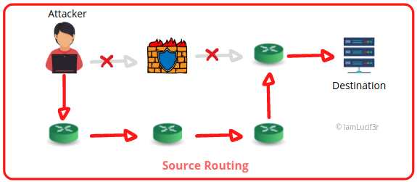

1. **Fragmentation**: Breaking malicious payloads into smaller packets to avoid detection.
2. **Obfuscation**: Encoding or encrypting the payload to prevent signature-based detection.
3. **Polymorphism**: Altering the payload's appearance with each attempt to avoid signature matches.
4. **Insertion and Evasion**: Sending packets with TCP/IP stack anomalies that the IDS might ignore but the target system will process.
5. **Flooding**: Overwhelming the IDS with traffic to reduce its effectiveness.

### **Evasion Techniques for Firewalls**

1. **Port Scanning**: Identifying open ports that can be used to bypass the firewall.
2. **Tunneling**: Encapsulating prohibited protocols within allowed protocols (e.g., using HTTP tunneling).
3. **Spoofing**: Forging the source IP address to bypass IP-based filtering rules.
4. **Protocol Manipulation**: Using non-standard port numbers or manipulating protocol headers to bypass filtering.
5. **Rate Limiting**: Sending traffic at a rate below the firewall's detection threshold.

### 

### **Evasion Techniques for Honeypots**

1. **Fingerprinting**: Identifying the honeypot by detecting its unique behaviors and characteristics.
2. **Low Interaction**: Minimizing interaction with the system to avoid triggering honeypot alerts.
3. **Avoidance**: Skipping systems that exhibit honeypot-like characteristics.
4. **Timing Attacks**: Interacting with the honeypot in a manner that mimics legitimate traffic patterns to avoid detection.

### **Tools for Evasion**

* **Nmap**: A network scanning tool that can perform stealth scans and identify open ports.
* **Metasploit**: A penetration testing framework that includes evasion modules.
* **Hping**: A packet crafting tool used for sending custom TCP/IP packets to test firewall rules.
* **Scapy**: A powerful Python library used for packet manipulation and crafting.

# **Capture the Flag (CTF) Challenges**

**Flag 1. What technique involves breaking malicious payloads into smaller packets to avoid IDS detection?**

**Answer:** Fragmentation

**Flag 2. Which tool is commonly used for network scanning and stealth scans?**

**Answer:** Nmap

**Flag 3. What is the term for encapsulating prohibited protocols within allowed protocols to bypass firewalls?**

**Answer:** Tunneling

**Flag 4. What method involves identifying the honeypot by detecting its unique behaviors?**

**Answer:** Fingerprinting

**Flag 5. Which technique involves forging the source IP address to bypass firewall rules?**

**Answer:** Spoofing